|  |
| --- |
| **APENDIX 5: TECHNICAL PAPER**  DECENTRALIZED CARPOOL SYSTEM  Kudakwashe Exstaff Kotia; Chibaya Yolandab  Department of Software Engineering, School of Information Sciences and Technology, Harare Institute of Technology, Harare, Zimbabwe  [kudakotie@gmail.com](mailto:kudakotie@gmail.com)a; [achibaya@hit.ac.zw](mailto:achibaya@hit.ac.zw)b; |

**ABSTRACT**

Existing carpooling optimization techniques based on a centralized approach serve policy makers' goals but neglect the reality of participants. Moreover, without strict enforcement, participants often ignore centralized solutions and maximize their own savings. We present a new heuristic, formulated and tested on real and simulated carpooling problem cases, that mimics the decentralized carpool self-organization process. Our findings reveal system-wide savings similar to centralized models and a potential strategy for improving carpooling use. Decentralized ridesharing is a system in which individuals can arrange rides with each other without the need for a centralized organization or platform. Instead, participants use a peer-to-peer network to connect with other riders or drivers traveling in the same direction.

This system enables more efficient use of resources, reduces traffic congestion and carbon emissions, and provides a more affordable alternative to traditional modes of transportation. The decentralized nature of the system also provides greater flexibility and autonomy for participants to arrange rides on their own terms without relying on a third-party platform or service. Overall, decentralized ridesharing has the potential to change the way we think about transportation and contribute to a more sustainable and equitable future. The system proposed by this study combines route customization, i.e seamlessly integrated with GPS, Google Maps, Android mobile app and Firebase database.

1. **INTRODUCTION**

The study focused on decentralized car sharing system using mobile phones specifically on the Android platform.

The car-sharing market is constantly growing and recently it has become popular more than car ownership. This classic car sharing system is based on a centralized database server which can often lead to hacker attacks or password leaks.

Moreover, in a classic car-sharing system the owners of the car can misuse customers’ data. Nowadays we have come to see from a lot of use cases, that the best solution is to use blockchain technology. The blockchain technology is decentralized, immutable, public ledger provides the customers with security that is impossible to tamper with. The aim of the proposed system is to create and implement peer-to-peer short term car-sharing application that is decentralized.

This project focused on providing a interactive way for drivers to connect with users in a decentralized way.

1. **PROBLEM STATEMENT**

Lately there is a problem of traffic on our roads and therefore the increasing fuel costs boost the misery of daily users of private vehicles. The number of vehicles plying on the road is rising as each day passes due to the low-cost cheap imports from Japan. This gives rise to few prime factors that square measure pollution, depletion and rising rates of fossil fuels and massive traffic congestion. The current system well known as mushika shika has been deemed illegal, with touts being suspected of rowdy behaviour which has resulted in the inconvenience of travellers. Other solutions at hand include taxi management system, in this system the taxi driver, passenger and management system are important entities. These components interact with one other in existing taxi management systems. Because of the widespread acceptance and use of smart phones in the real world, we assume that each 1 passenger and taxi driver is equipped with a smart portable communication device, such as a smart phone or a computer. Each passenger contributes to the cab management centre, he/she must communicate his/her present position and desired destination.

The taxi management centre must be established, send the taxi to carry the passengers efficiently from their designated starting points to the intended destinations. Taxi drivers who are available to convey the passenger will react to the taxi management centre to express their desire to pick up the passenger. The cab control centre then moves on to the next passenger's request.

. The previously described practice of existing taxi management systems has various drawbacks. For example, passengers in a single cab cannot readily share a journey with one another to reduce costs. The transportation system is inefficient. As a result, there is no way to minimize air pollution and carbon emissions. Carpooling entails two or more passengers traveling in the same direction in a private car along a partially shared route. The idea of carpooling is that some individual passengers' journey time is sacrificed in order to receive additional benefits such as sharing driving costs, parking fees, reduced traffic congestion, or lower carbon emissions. Unfortunately providing carpooling with general systems to users brings a lot of security flaws, first of all is overall stability of service.So decentralization will add transparency and ensures data protection as it is termed an unchangeable method.

1. **RELATED WORK**

**HireGo**

It is built on Ethereum using smart contracts as a distributor of virtual fungible tokens (standard ERC-20) [1] called HGO. If one wants to rent a car using HireGo, he or she has to exchange ETH to HGO tokens. HireGo’s market places has three contracts. The first contract of HireGo provides HGO tokens and the ERC-721 car tokens are provided by the second contract and lastly the third contract provides rental contract. The rental contract is responsible for Vehicle token between two parties and also acts as an escrow. So what happens is when one wants to rent a car, he or she sends HGO tokens to rental smart contract which locks car token and HGO tokens for selected period. After this the contract then manages the transfer of the vehicle token from owner to us. The rental solution also comes up with big security issue. If we rent a car for a day trip and then we lose the phone with Ethereum address, the car will be stuck for the rest of time and the owner is unable to help us because he/she does not own that vehicle at the time of renting.

**Helbiz**

Its philosophy is to create and integrate transport ecosystem where users are rewarded for using this system. The project is using well-known implementation of blockchain car-sharing platform by providing ERC-20 tokens called HBZ. If the user does not have enough tokens, the application offers the user to but the HBZ tokens through the use of credit card.

**DAV**

Its main goal is to connect autonomous vehicles with users. The use the DAV token for communication and this DAV token also acts as an access token, Services in the DAV network can be bought with virtual tokens based on Ethereum. If a person is owning a vehicle or charging station which he or she is providing to other users in the network he or she is rewarded with DAVE tokens [2]. Autonomous vehicles automatically interact with environment and also can fulfil user’s commands.

**FFQuest**

Its main strength is the use of their own chain called Distributed FFQ Ledger based on Ethereum Virtual Machine. All the transaction details between car companies, drivers and customers such as payment conditions, assets, availability and reservations by using their own utility token type ERC-20 called FFQ are passes by the ledger. This project uses central backend to mirror Distributed FFQ Ledger on a server and also for storing videos and images [3].

**WONO**

It provided a decentralized market for renting services such as cars and working man days. They used a set of smart contracts that work as a bridge between Ethereum main net and their blockchain. Their blockchain uses Proof-of-stake algorithm to ensure consensus in the network. The IPFS file system which is a decentralized system is used to store users; profile data represented as JSON. Data properties which contain confidential information are encrypted on a client’s app side by a public key of the User’s address and can be decrypted only by the privatekey [4].

**Meshkani**

With blockchain technology emerging quickly, significant efforts are being made to incorporate this technology in the transportation sector. Meshkani [5] suggested an empirical ride sharing method where individual users can share their ride with only a single user. Lei [6] and Abbas [7] have suggested decentralized data management systems that are integrated with blockchain and IoT to provide better transparency, data sharing and tracking.

1. **SOLUTION**

Arners In recent years, the problems of global warming and the energy crisis have aroused widespread public concern. One recommended solution for reducing the harmful factors leading to such problems is carpooling. This type of transportation service could make a big difference if organized on a large scale by government or big companies, particularly large corporations with many branches or subcompanies. Carpooling schemes are designed to encourage commuters to share travel expenses and resources with colleagues. The proposed system overcomes the drawbacks of the existing system. It has advanced facilities to make it more user-friendly. It provides details of the owner and his/her car to maintain transparency between users of the system. It will track the location of users those who are involved in the pool through GPS Navigation system.

##### OVERVIEW OF THE PROSED SYSTEM

Users:

Two types of users are involved in the proposed system that is the driver and passenger.

Passengers:

Passenger is any person that doesn’t own a car and wants to join a rider in a ride. The passenger posted and conditions specified (price and general agrees to all the behaviour).

Find ride and choose ride:

When a rider goes to the sent requests he or she can see the available rides from the drivers. He or she can see the driver nearest to him through the shown distance. The rider can choose the ride of his or her own writing. A notification is sent to the driver notifying him or her of the rider who has joined the ride.

Driver:

Driver is the person providing carpooling Services using his own car.

Schedule ride and choose passenger: The driver can create a new ride to be displayed when passengers search for ride. The application will prompt the information of the ride which consists of destination, origin, meeting, departure time/date, estimated arrival time and travelling preferences. The driver accepts the passenger seeking ride if he/she meets the requirements of the trip.

Profile registration

System’s users have their own profiles, where they store a description and have important information. The available information is the description provided by the user, name to be recognized, workplace or education institution the user is inserted in and vehicle information if it is the case of a driver. At the same time these profiles, depending on what info is available, give to other users some validation and trust when it comes to share a trip.

User Alerts

When important actions occur, users get a notification warning for those, for example, that their status in the lift has been changed, either because his request to join the lift has been accepted, or denied, or the lift itself has been cancelled. This is important because, smart phone users do not have time to check all their applications for updates, instead, the applications must notify the users if such updates exist or else they will just go unnoticed.

1. *Solution Architecture*

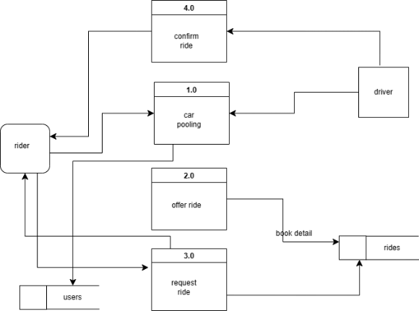

*Figure 1: DFD level 1*

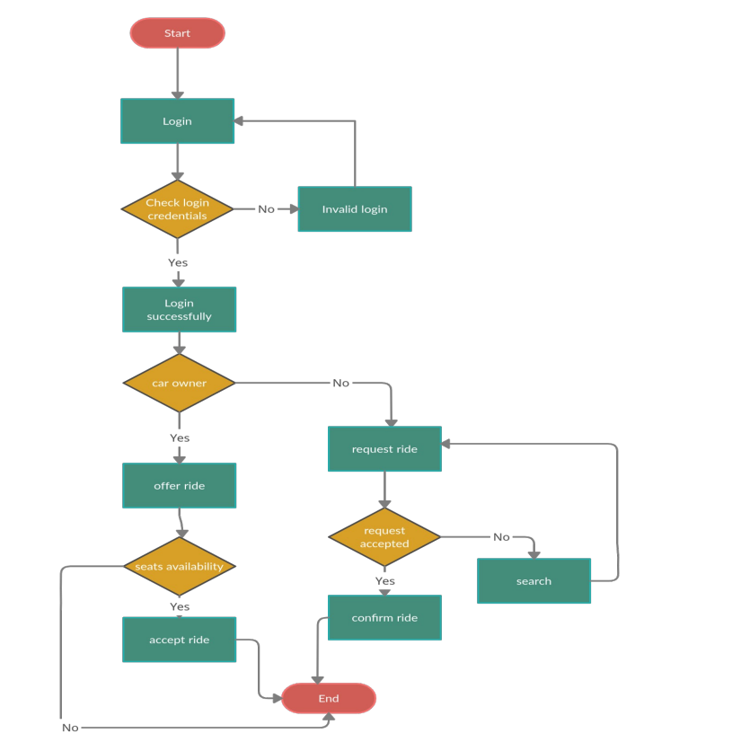

*Figure 2: Activity Diagram of the proposed system*

1. *Coding Strategy*

The coding strategy is the series of steps taken to accomplish all the objectives in a project. As the size of this project was big, this project was divided into different modules. The structure and relationships between classes was defined first before the classes where created. Some of the features that were developed using trial and error until the desired results were obtained.

1. *Experimentation and Testing*

|  |  |  |
| --- | --- | --- |
| **Domain** | **Expected Results** | **Actual Results** |
| Functional Testing | * The system modules should function as expected. * The system should be easily accessible and user friendly. * Error messages should be displayed on the   system. | As expected |
| Integration Testing | All the integrated modules should work  together flawlessly. | As expected |
| System Testing | All the components of the system should  function properly. | As expected |
| Acceptance Testing | The system should meet user requirements and  system objectives. | As expected |

1. **CONCLUSION**

This study features a unique methodology for the Decentralized Rideshare model, which aims to establish ideal matches between passengers wanting rideshare services and relevant drivers ready to carpool. The server continually gets information and preferences from passengers and drivers, and passengers to drivers in terms of closeness in time and place, as well as compatibility of traits and preferences among passengers, drivers, and passengers on board. This paper elaborates on the proposed system, which is made up of three primary modules: Offer a ride, Seek a ride and user verification via Registration. This system uses Google Maps services and a GPS module to create user-specific services. It eventually leads to the construction of a well-organized transportation facility. It is a program targeted at lowering fuel usage and carbon emissions. As a result, it is an environmentally beneficial application. The primary goal of this study is to present the preliminary prototype of the suggested system.

We now realize that mobile technology is a broad and deep subject to master, that there are multiple ways to leverage it, and that app development is challenging and requires extensive planning and optimization. Decentralized carpooling is an effective way to reduce air pollution, parking problems, fuel consumption, commuting costs based on shared use of private cars or vehicles, mismanagement of user data, and also to increase the transparency of the system. In this paper, we study the carpooling problem and develop a decentralized carpooling prototype to implement ridesharing on the smartphone platform and Google Map API. Our proposed decentralized mobile ridesharing app aims to generate a simple ridesharing app that can help passengers and drivers and ensure no privacy violations. Finally, and after understanding the mobile technologies and solutions available for use, and understanding how car sharing work, we can determine the best options to use to build our app.

1. **FUTURE WORK**

The decentralized car sharing application project has opened up many possibilities for future work and improvements. Some of the areas that could be explored include:

* allowing user to comment to an event could improve the coordination among users. Driver rating technique if used to give a feedback about the drivers and also in application chatting between the passengers and drivers.
* Use of recommendation algorithms to recommend drivers to passenger. Use of neural network algorithms such as Convolution Neural Network (CNN) pooling system can be for transportation goods in sharing manner (Truck Pooling).
* Using ads within the pages of the application it can also be used for advertising.
* To deploy the application on Google Play Store and have another application for IOS and windows phones.
* Use blockchain rather than databases

**BIBLIOGRAPHY**

**Kudakwashe Exstaff Koti** is a final year student studying Software Engineering at HIT

**REFERENCES**

[1] Nakamoto, S.: ‘Bitcoin: A peer-to-peer electronic cash system’, in Editor (Ed.)^(Eds.): ‘Book Bitcoin: A peer-topeer electronic cash system’ (2008, edn.)

[2] Teigland, R., Yetis, Z., and Larsson, T.O.: ‘Breaking out of the bank in Europe-exploring collective emergent institutional entrepreneurship through bitcoin’, Available at SSRN 2263707, 2013

[3] Helbing, D.: ‘Systemic Risks in Society and Economics’, in Helbing, D. (Ed.): ‘Social self-organization: Agent-based simulations and experiments to study emergent social behavior’ (Springer, 2012)

[4] Meiklejohn, S., Pomarole, M., Jordan, G., Levchenko, K., McCoy, D., Voelker, G.M., and Savage, S.: ‘A fistful of bitcoins: characterizing payments among men with no names’, in Editor (Ed.)^(Eds.): ‘Book A fistful of bitcoins: characterizing payments among men with no names’ (ACM, 2013, edn.), pp. 127-140

[5] Barber, S., Boyen, X., Shi, E., and Uzun, E.: ‘Bitter to better—how to make bitcoin a better currency’, in Editor (Ed.)^(Eds.): ‘Book Bitter to better—how to make bitcoin a better currency’ (Springer, 2012, edn.), pp. 399-414

[6] Laidler, D.: ‘The definition of money: theoretical and empirical problems’, Journal of Money, Credit and Banking, 1969, 1, (3), pp. 508-525

[7] Brezo, F., and Bringas, P.G.: ‘Issues and risks associated with cryptocurrencies such as Bitcoin’, 2012